Session 3: Healthy Beverages and Snacking

Objectives  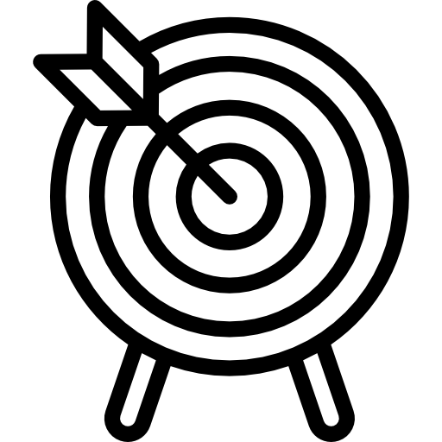 | - Participants will be able to: list snacks and drinks that are in the GREEN food group  - Identify the amount of sugar in common beverages  - Identify which snack is healthier
Supplies | - Oral Health Kansas (OHK) Sugary Drinks pictures  - Healthy snacks pictures
Activities | - Body Movement Activity  - Sugary Drinks Activity  - Guess the Healthier Snacks  - Wrap Up

Session 3 Activities and Scripts
Welcome (5 minutes)
Welcome back to the Stoplight Healthy Living Program! Do you remember how we introduced ourselves at the first session?
(Facilitators introduce themselves with their movement.)

Now, please introduce yourself like we did last time with your special body movement.

Have participants stand (if able to) or sit in a circle. Each participant should say their first name out loud to the group and then follow it with their body movement — large or small. The group will then say the participant’s name out loud and then repeat his or her body movement.
This activity will begin each session to remind participants of each other’s names and to start the session off with some movement. They should repeat their unique body movement each week. (If any participant forgets their body movement, feel free to remind them or just have them create a new one!)
Sugary Drinks
Before starting, prepare the Sugary Drinks pictures to display.
Today we are going to talk about sugar. Who loves sugar? Yes- we all do. But too much sugar can harm our bodies. It can lead to diabetes and other health problems. We might be getting too much sugar from what we drink. Today we have a display of many types of drinks that we have all probably seen or drank before. We are going to show how much sugar is in each drink. You will probably be surprised!

Choose a picture of a beverage with lots of sugar, such as soda pop.
How much sugar do you think is in this bottle? How many spoons of sugar?
Let the participants guess how much sugar is in the beverage. After getting their responses, show them the picture with the number of spoons.
Let’s have each of you try to guess how much sugar is in another drink.

Give each participant an opportunity to guess the amount of sugar in a beverage. When everyone has had a chance to guess, line up the pictures of the beverages on a table with the pictures of spoons of sugar next to the correct picture (or tape them to the walls.) Discuss with the participants what beverages are healthier to have

Which drink do you think is the best for you to drink most of the time?
Which drinks do you think should only be for very special occasions?

Sugar is not good for bodies or teeth. Did you know that if you are drinking a sugary drink, it is better to drink it all at once and not sip it for a long time? When you sip it, the sugar stays on your teeth longer and that can hurt them.

Think about the amount of sugar in beverages the next time you drink something. Water does not have any sugar in it and that helps your body in so many ways. It also costs less money.

Guess the Healthier Snacks
A large space will be needed for this activity. Participants will be moving to “vote” for the healthier snack. The two facilitators stand 12-15 feet apart and each holds up a picture of a snack item. Ask participants to move to the snack that they think is healthier.
Now we are going to play a game called “Guess the healthier snack.” The facilitators will hold up photos of two different snack foods. We want you to look at both photos and then walk or wheel over to the one that you think is healthier and better for your body. Don’t pay attention to what others are doing-- just go over to the one that you think is best for you to eat.
Be sure match up the correct items for each pair, and to describe what is in the photos so that participants understand the details of their choices. After participants vote with their feet or wheels, explain why the healthier choice is healthier so that participants learn from the activity.
Here’s how these snacks compare:
  - Pair 1: Two cookies vs. a handful of carrots (Carrots are healthier as they have less sugar, salt, and help us eat our daily vegetables They are in the GREEN group.)
  - Pair 2: Small bag of potato chips vs. sliced apple with peanut butter (The apple is healthier—it has less salt and is in the GREEN group, plus peanut butter has protein.)
  - Pair 3: Whole-wheat crackers with hummus vs. baked potato chips (Whole-wheat crackers with hummus are healthier--they give us a serving of whole grains, and some protein in the hummus. The baked potato chips have less fat than regular potato chips but are high in salt and do not provide a fruit or vegetable.)
  - Pair 4: Full fat strawberry yogurt vs. piece of string cheese (String cheese is healthier—it has less sugar and less fat and is a YELLOW food. If the yogurt were fat-free or low-fat and had low sugar, it could be as healthy as the string cheese. Full fat is in the RED group)
  - Pair 5: Trail mix or nuts. (Nuts are the healthier option because they have more protein than trail mix and because trail mix often has sugary M&Ms or chocolate pieces.)
  - Pair 6: Banana or chocolate-dipped strawberry. (The banana is healthier. Even though the strawberry is a GREEN food, the chocolate dip makes it less healthy than the banana.)
  - Pair 7: Cucumber with dip or pretzels. (The cucumber with dip is healthier because cucumbers are in the GREEN group. Pretzels have too much sodium and are in the YELLOW group.)
  - Pair 8: Muffin or donut. (Both are not very good choices, but the muffin may be a little better because it probably has less fat and sugar and may have some fruit or whole grain in it Both of these foods are in the RED group.)
  - Pair 9: Tortilla chips with cheese dip or popcorn. (Popcorn is a healthier choice, especially if it is air popped or with no butter. Fat-free popcorn-no butter—is in the GREEN group. Both tortilla chips and cheese dip have a lot of salt and fat and are in the RED group.)
  - Pair 10: Milkshakes or celery with peanut butter. (Celery with peanut butter has protein. Celery is a GREEN food and peanut butter is a yellow food. Milkshakes typically have a lot of fat and sugar and are a RED food.)

Can anyone remember which snacks on the pictures are in the GREEN-Go food group?

Discuss and help participants correct any misperceptions.

Wrap Up
Today we learned:
- that many common drinks have too much sugar and are not healthy
- how to choose heathier snacks and drinks from the GREEN-Go group
- that water is the healthiest thing we can drink
At the next session, we will talk about how we can make our favorite meals healthier.

