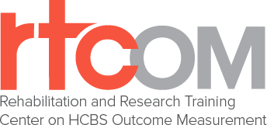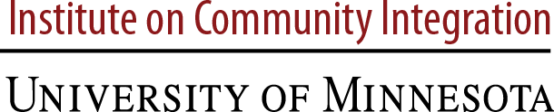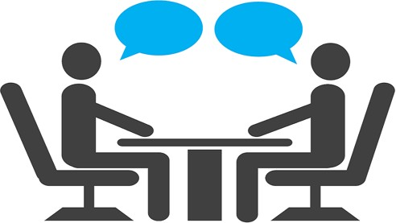
We Need Your Help!
Research Participants Wanted for Interviews
We are testing measures to improve person-centered Home and Community-Based Services (HCBS) outcomes for people with disabilities
Getting services at home or in the community is important for people with disabilities. To make those services better, we need to know if and how the services are working. We are testing measures that include questions about how well Home and Community-Based Services (HCBS) are helping people live the lives they want. We need your help to make sure the measures provide valuable information.

In this research study, we will meet with you over Zoom. We will talk with you and ask questions about some important areas of your life. We may record the interview.
To take part, you must:

Be at least 18 years old.
- Be getting services from the TBI Waiver, PD Waiver, I/DD Waiver, FE Waiver or Working Healthy/WORK.
- Provide consent or assent (if not your own legal guardian).
- Be willing to take part in a 60-90 minute interview at three separate times over a 1-year period.
Everyone we interview will get a $10 gift card for each interview

IF YOU OR SOMEONE YOU WORK WITH IS INTERESTED OR HAVE ANY QUESTIONS PLEASE CONTACT:
Noelle Kurth at the University of Kansas (KU)
Phone: (785) 864-7085 or Email: pixie@ku.edu

This research study is overseen by co-directors of the Research and Training Center on HCBS Outcome Measurement, Dr. Brian Abery (abery001@umn.edu) and Dr. Renáta Tichá (tich0018@umn.edu) at the University of Minnesota Institute on Community Integration.

