Session 4: Healthy Meal Preparation

Objectives  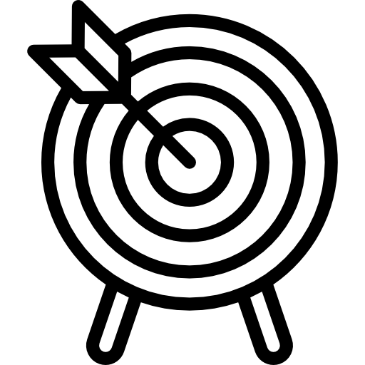 | Participants will be able to:  - describe ways to make common foods healthier  - use their hands to measure healthy portion sizes
Supplies  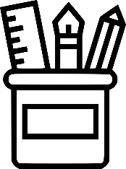 | - Supplies for measuring portions activity (optional for demonstrating portion sizes): Deck of cards, container of playdough, cup of dry beans, small bag of pretzels
Activities  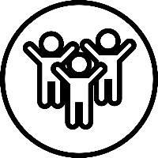 | - Welcome  - Movement Activity  - Handy Portions  - Healthy Meals  - Wrap up

Session 4 Activities and Scripts
Welcome
Welcome back to the Stoplight Healthy Living Program!
Do you remember how we introduced ourselves at the last three sessions?
(Facilitators introduce themselves with their movements.)

Please introduce yourself like we did last time with your special body movement.

Ask participants to stand (if able to) or sit in a circle. Each participant should say their first name out loud to the group and then follow it with their body movement — large or small. The group will then repeat the participant’s name out loud and then repeat his or her body movement.

This activity will start each session to remind participants of each other’s names and to start the session off with some movement. They should repeat their unique body movement each week. (If they forget their movement, they can choose a new one.)

Handy Portions
Portion means the amount of food you eat at one time.
It can be hard to know what the right portion is for good health. We need to think about portions so that we don’t eat too much. Serving sizes, like what we get on our plate when we eat out, have gotten bigger and bigger over the years — but that does not mean that our portions should that big or that we should eat so much food at one time.
We can use our hands to figure out how big a portion of different foods should be.
Distribute Handy Portions handouts and refer to them as you speak. Ask participants to identify their thumbnail, to cup their hands, etc. to practice measuring the correct amount.
For fats like butter, margarine, mayonnaise, and oils, look at your thumbnail. Portions of these foods should only be as large as your thumbnail. That’s a small portion because these foods have a lot of fat.
Measure out small portions of play dough and place some on each participant’s thumbnail to demonstrate how much butter or mayonnaise should be eaten as one portion. Ask participants if that is the amount that they might usually have on a sandwich, or on pancakes.
For proteins like chicken, beef, pork and fish, your portion should be the size of your palm. See how the palm is outlined in this photo?
Pass around a deck of cards (picture attached at the end of this manual in case a deck isn’t available) and explain that a serving of meat should be no bigger than the size of a pack of cards. So, they can use the palm of their hand or think about the size of a deck of cards to decide how much meat or fish to eat at one meal.
If you are having beans, dry cereal (such as Cheerios) raw veggies or fruit, the serving should be the size of your fist.
Ask a participant to pour out a serving of beans that is about the size of his or her fist onto a napkin or paper towel (picture attached at the end of this manual in case a beans aren’t available). Give feedback in whether it is the right amount or seems like too little or too much. Pour the beans back into the container and ask other participants if they would like to try it. Tell them that an average sized apple or orange is about the size of a fist.
For servings of salad dressing, cheese or peanut butter, your portion should be the size of your thumb. See how the thumb is outlined in this picture?
Ask participants if a serving about the size of their thumbs is what the typically eat. If they have a piece of cheese, is the portion about that size? Do they usually have that much salad dressing? If they have a peanut butter sandwich, is a portion the size of their thumb about what they usually have? Discuss typical portion sizes and how they might adjust them in light of this new information.
If you are having a rare treat like chips, crackers or pretzels, which are RED foods, a serving size would fill two cupped hands — so not a quarter or a half of a bag, but just enough to fill two cupped hands.
Ask for a volunteer to cup his or her hands and pour enough pretzels into the cupped hands to fill them (picture attached at the end of this manual in case pretzels aren’t available). Then have the participant pour the serving onto a napkin or paper towel to see what that amount looks like. Discuss how that is the right-sized serving and that when eating foods with a lot of fat and/or salt, it is important to eat a smaller portion versus half of a big bag. Ask if any other participant wants to fill his or her hands. Remind participants NOT to eat the food that has been handled!
If you are having pasta, rice, potatoes or nuts, cup your hand, like this. What you can fit in one hand is the right portion of these foods.
Mention that a serving of pasta in a restaurant is often 2-3 times the amount that can fit in a cupped hand. But when eating at home, it is easier to control portion sizes.
If you are having greens, lettuce or raw spinach (like you would put in a salad), the right serving size is the amount equal to two fists.
It is not as much of a problem to have larger portions of GREEN foods like greens, lettuce, spinach, and other greens. These are healthy foods that we should eat more of.
Can you think of any foods that you eat regularly that you have in serving sizes equal to one fist?
How about two fists?
Take these handouts home as a reminder of what the right portion sizes are for different foods, so that you can eat well and be healthy. This is especially good to know when you eat out, because restaurant servings are often 2-3 times the size of servings we have at home. Remember that if you get a big serving at a restaurant, you can share it with another person, or you can have some of the food boxed up to bring home. Then you can enjoy it later. You can control the size of the food portions that you eat.
Remember how to measure with your hands when you want to know the right portion sizes!
How to Make Foods and Meals Healthier (15 minutes)
Let’s talk about how to make the foods that we like healthier. Many of the foods that we eat are made up of a combination of foods, like macaroni and cheese or tacos. We can try to increase the amount of GREEN foods in a recipe and use fewer YELLOW and RED foods.
How many people like macaroni and cheese? How about tacos? How about burgers?
Distribute “How to Make Foods and Meals Healthier” handout.
Okay, Let’s start with macaroni and cheese. This is made of pasta and cheese sauce and it is a YELLOW or Slow food. So, first, you can start with a whole grain pasta, which has more nutrition than refined grains. There are also pastas made with beans that are more nutritious and you won’t even taste the difference. Has anyone ever had whole grain or bean pasta? It tastes good—you might not even notice any difference from regular pasta.
Then you can substitute a vegetable, like butternut squash or cauliflower, for some of the macaroni. This is a way to increase the number of veggies on your plate and it tastes good. Has anyone ever had macaroni and cheese with veggies in it?
You can use skim or 1% or 2% milk to make the sauce instead of whole milk. You can also reduce the amount of cheese in the sauce — using extra sharp cheese will give you a lot of flavor while you reduce the amount of cheese by 1/3 to 1/2 cup. This will cut down the fat and calories.
Of course, if you can’t do this at the cooking stage, you can also control how much macaroni and cheese that you put on your plate to make a healthier meal. Try asking for or taking a one-half portion and filling your plate with more vegetables. You can still enjoy the gooiness of mac and cheese but get your veggies in, too.
Who likes tacos? Tacos are made of a lot of different foods. The shell is made of grains, you have some protein in the meat or beans, some veggies in the lettuce and tomato on top, and then some dairy in the cheese and sour cream.
So how do we make tacos healthier? First, we can have one or two tacos instead of three. We can ask for less meat or substitute some beans or some fish. Think about a portion of meat, such as beef or chicken, the size of your palm (use portion chart) distributed over two tacos.
We can pile on the veggies like lettuce and tomatoes, which are GREEN foods, and leave off or only use a little cheese and sour cream. Try having salsa on your taco and skip the sour cream. These are all ways to have a healthier taco that is still delicious. And let’s think about what you usually have with tacos. If you usually have rice and refried beans, try substituting a salad and some cooked beans that are not refried. Refried beans contain a lot of fat.
Who likes burgers? There are ways to make a good burger healthier too. First, get a single not a double burger and leave off the bacon and cheese. One burger will give you all the protein that you need. More than that will go way over the portion size for protein. Then, think about toppings. Instead of cheese, bacon, onion rings, etc., try veggies—lettuce, tomato, pepper rings, onions, or other veggies that you like.
Try leaving the top of the bun off—that would make an open face burger. Can you have a whole grain bun instead of a white bun? That would be healthier. If you usually have fries with your burger, try having a salad and/or splitting a small order of fries with someone else. Don’t add any salt to your fries. Also, have only a little ketchup—it has a lot of salt in it. You can still enjoy a good burger that is both tasty and healthy.
If you’re having a snack, you can find ways to both enjoy it and stick with your healthy eating plan. Veggies and dips are a good way to get your servings of veggies in. Go light on the dip, though – it doesn’t take much to make it delicious. Fruits are also good for snacks. An apple or orange, a handful of grapes, or a slice of melon are all good snacks. Fruits and veggies are GREEN foods so you can eat a lot of them. What other fruits and veggies make good snacks??
Low-fat yogurt without a lot of sugar is also a good snack. It is a healthy dairy food. A low-fat cheese like string cheese can also be good, but only a small portion and not all the time. Baked chips can be good, but not all the time as they are a YELLOW food.
Some other snacks are less good for you. Candy, cookies, cake, brownies, ice cream – these are all RED foods and even though we like them, they are not very healthy for us so we should eat them only rarely as a special treat.
What healthy snacks have you had recently? What healthy snack do you plan to eat next week?
So, remember, whether you’re having a meal or a snack, choosing more foods from the GREEN list will make you healthier and will help you to feel better. Save the YELLOW foods for once in a while and try to stay away from the RED food group.
Distribute pictures of healthy meal ideas and discuss why these meals are healthy.
Wrap Up
We did many activities today. We practiced learning how we can use our hands to understand healthy portions of many foods. We talked about how we can make common foods that we like a little bit healthier — that can help us with our goal to make small changes every day.
We just finished our fourth session and we have two more to go. Everyone has learned so much.
Remember to measure your portions and drink lots of water!

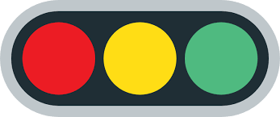
Stoplight Healthy Living
How to Eat Healthier
1. Add vegetables
For spaghetti sauce, add peppers, carrots, onions or other veggies instead of meat
For macaroni and cheese, add cauliflower or buttnernut squash with cooked pasta
For tacos, add chopped tomatos, peppers, onions and beans and cut back on meat,
cheese and sour cream
For burgers, top with lettuce, tomsatos and other veggies instead of cheese.
2. Eat less bread
For burgers, eat only half of the bun—it’s easy to leave the top of the bun off
Try eating just half a sandwich along with a piece of fruit or some raw veggies and dip
3. Cut back on fried foods
Instead of French fries with a burger, have a salad or a piece of fruit
Split an order of fries with a friend so you eat fewer
If having potato chips, choose baked instead of fried
Ask for baked chicken or fish instead of fried
4. Skip dessert or try a healthier one
Save cake, pie, and pastry for special days like birthdays and holidays
Have a piece of fruit, like an apple or an orange, for dessert
Instead of a sugary dessert, try a yogurt parfait with fresh fruit
5. Drink water
Skip the sugary drinks and have water during the day and with meals If you have soda pop, have diet soda
Remember to:
Eat more foods from the GREEN group—fruits and vegetables!
Put a variety of foods on your plate as in My Plate
Watch your portion sizes
Drink more water
(Think of ways to eat at least five fruits and vegetables each day!)

